SIMATS ENGINEERING
ASSESSMENT TOOL 1: Agent Design Assessment
COURSE NAME: ARTIFICIAL INTELLIGENCE AND EXPERT SYSTEMS
COURSE OUTCOME COVERED
COURSE CODE: MLA0104
CO1: Apply search algorithms and heuristic techniques to solve state-space search and optimization problems. (BTL 3)
Assessment Tool Weightage: 55 %
Total Marks: 50 Time: 60 Mins No. of Questions: 1
Annexure A
Agent Design Assessment
Code of Conduct:
I (M. Sanjay Krishna / 192525421) certify that this submission is my original work and that I have adhered to the guidelines specified for this assessment. I understand that any violation of academic integrity rules will result in disciplinary action.
Signature of the student:

Question | Problem  Understanding & AI Concept Identification | Dialog flow Agent Design &  Implementation | Problem  Formulation &  Conversation Flow Design | Application of AI Techniques & Reasoning | Testing,  Evaluation & Documentation | Total
Weightage | 20% | 30% | 20% | 20% | 10% | 100%
Q1

Signature of the Faculty : Total Marks Awarded:

Scenario
A university wants to develop an AI-based Student Support Assistant to provide instant responses to student queries related to course registration, timetable, examination schedules, attendance details, and campus services.
As an AI developer, design and implement a conversational agent using Dialog flow that can understand user requests, process intents, and provide appropriate responses.
AI-Based Student Support Assistant Using IBM Watson Assistant
Abstract
Universities receive numerous student queries related to course registration, timetables, examinations, attendance, and campus services. Answering these queries manually can be time-consuming and increase the workload of administrative staff. An AI-powered chatbot developed using IBM Watson Assistant can provide instant, accurate, and 24/7 support. The chatbot uses Artificial Intelligence (AI), Natural Language Processing (NLP), and Machine Learning (ML) to understand user queries, identify intents, and generate appropriate responses. This project focuses on designing an intelligent Student Support Assistant that improves communication, reduces response time, and enhances the overall student experience.
Introduction
Students often need quick access to academic information such as examination schedules, class timetables, attendance details, and course registration. Traditional support systems depend on administrative staff, which may result in delays, especially during busy periods.
An AI-based Student Support Assistant can solve this problem by providing instant responses through a conversational chatbot. IBM Watson Assistant, the chatbot understands natural language, identifies user intentions, and delivers accurate information. This improves efficiency while reducing the workload of university staff.
Problem Analysis
Existing Problems
- Delay in responding to student queries.
- Limited office working hours.
- High workload for administrative staff.
- Inconsistent information from different departments.
- Students experience long waiting times.
Proposed AI Solution
The proposed chatbot automates student support by:
- Answering queries instantly.
- Providing 24/7 assistance.
- Reducing manual work.
- Delivering accurate and consistent responses.
- Improving student satisfaction.

3. Agent Design
Component | Description
Agent Name | IBM Watson Assistant
Objective | Provide instant support for student queries
Users | Students, Faculty, Administration
Inputs | Student questions
Processing | NLP, Intent Recognition, Entity Extraction
Outputs | Relevant responses
Performance Measures | Accuracy, Response Time, User Satisfaction

Dialog flow Agent Development
The AI Student Support Assistant is developed using IBM Watson Assistant, which enables the chatbot to understand student queries through Natural Language Processing (NLP). The chatbot identifies the user's intent, extracts important information (entities), and provides an appropriate response. This makes the interaction simple, fast, and user-friendly.

1. Intents
Intents represent the purpose of a student's query. The chatbot is designed with the following intents:
Intent Name | Purpose
Welcome Intent | Greets the user
Course Registration | Provides registration details
Timetable | Displays class timetable
Examination Schedule | Provides exam dates and timings
Attendance Details | Shows attendance information
Campus Services | Gives information about library, hostel, transport, etc.
Default Fallback Intent | Handles unknown queries

2. Entities
Entities help the chatbot identify important information from the user's query.
Entity | Example
@course | AI, Data Science, Python
@semester | Semester 1, Semester 2
@date | Monday, 15 July
@department | CSE, ECE, IT
@service | Library, Hostel, Transport

Training Phrases
Training phrases teach Dialogflow how students may ask questions.
Intent | Example Training Phrases
Course Registration | "How do I register for courses?", "Course registration details"
Timetable | "Show my timetable", "Today's class schedule"
Examination Schedule | "When is my exam?", "Exam timetable"

Responses
After identifying the intent, the chatbot provides suitable responses.
Intent | Sample Response
Course Registration | "Course registration starts on 10 August through the student portal."
Timetable | "Your timetable is available on the university portal."
Examination Schedule | "The examination timetable will be published one week before the exams."
Attendance | "Please log in to the student portal to view your attendance percentage."
Campus Services | "The library is open from 8:00 AM to 8:00 PM."

Contexts
Contexts help maintain the flow of conversation by remembering previous interactions.
Example:
Student: Show my attendance.
Bot: Which semester?
Student: Third semester.
Bot: Your attendance for the third semester is 92%.

Dialogflow Agent Workflow: Student
│
▼
Enter Question
│
▼
IBM Watson Assistant Receives Query
│
▼
Intent & Entity Detection
│
▼
Match Appropriate Intent
│
▼
Generate Correct Response
│
▼
Display Reply to User

Problem Formulation and Conversation Flow
The Student Support Assistant can be viewed as an AI problem-solving system. The chatbot starts from the user's query, identifies the appropriate intent, and provides a relevant response. The objective is to satisfy the user's request accurately and efficiently.

Problem Formulation
Initial State
The chatbot is idle and waiting for the student to enter a query.
Goal State
The chatbot correctly understands the student's request and provides an accurate response.
Possible Actions
- Receive the student's query.
- Identify the user's intent.
- Extract relevant entities (if required).
- Retrieve the appropriate information.
- Generate and display the response.

State Transitions
Current State | Action | Next State
Waiting for Query | Student enters a question | Query Received
Query Received | Detect intent | Intent Identified
Intent Identified | Retrieve information | Response Generated
Response Generated | Send response | Goal Achieved

Conversation Flow Diagram: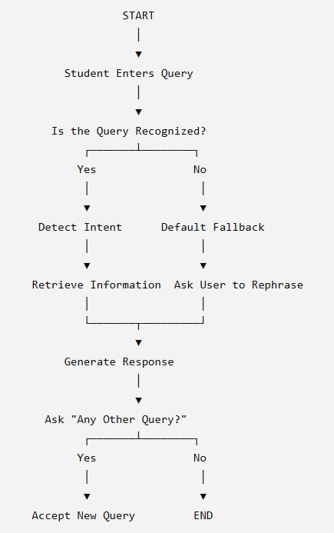

Example Conversation
Student: Hello
Bot: Welcome! How can I help you today?
Student: When is the examination timetable released?
Bot: The examination timetable will be published one week before the exams.
Student: What is my attendance?
Bot: Please specify your semester.
Student: Third Semester.
Bot: Your attendance details are available on the student portal.

Search Strategy Application
Search techniques in Artificial Intelligence help a chatbot select the correct response by exploring possible intents based on the user's query. For the Student Support Assistant, Breadth-First Search (BFS) is used to model the intent selection process because it systematically checks all possible intents at the current level before moving deeper. This ensures that the chatbot identifies the most appropriate intent efficiently.

Search Strategy Used: Breadth-First Search (BFS)
Breadth-First Search (BFS) is an AI search algorithm that explores all neighbouring nodes level by level until the desired goal is found.
In this chatbot, the user query is treated as the starting node, and each possible intent is considered a child node. The chatbot compares the query with all available intents and selects the best matching one.

Why BFS is Used?
BFS is suitable for this application because:
- It checks all possible intents systematically.
- It helps identify the correct intent quickly.
- It is simple to implement and understand.
- It reduces the chance of selecting an incorrect response.
- It works effectively when the number of intents is limited.
BFS Intent Selection Flow:

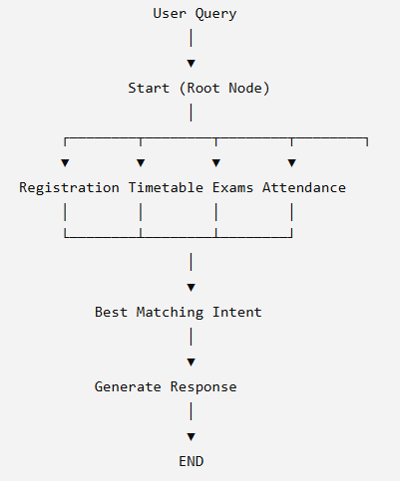

Testing and Evaluation
After developing the Dialogflow chatbot, it is important to test its performance using different student queries. The testing process checks whether the chatbot correctly identifies user intents, provides accurate responses, and handles unknown queries effectively. This helps ensure that the chatbot delivers a reliable and user-friendly experience.

Test Cases
Test Case | User Query | Expected Result | Status
TC1 | How do I register for courses? | Displays course registration details | Pass
TC2 | Show my timetable | Displays timetable information | Pass
TC3 | When are the exams? | Shows examination schedule | Pass
TC4 | Check my attendance | Requests semester and displays attendance | Pass
TC5 | What are the library timings? | Provides library working hours | Pass
TC6 | Tell me a joke | Activates fallback intent | Pass

Evaluation
The chatbot was evaluated based on the following factors:
Accuracy
The chatbot correctly identified the user's intent for most common student queries and generated relevant responses.
Response Quality
Responses were clear, informative, and easy to understand. The chatbot answered queries in a conversational manner, improving the user experience.

Sample Conversation:
Student: Show my timetable.
Bot: Your class timetable is available on the university portal.
Student: What are the hostel timings?
Bot: The hostel office is open from 9:00 AM to 5:00 PM.
Student: Tell me today's weather.
Bot: Sorry, I couldn't understand your request. Please ask a question related to university services.

Improvements
The chatbot can be enhanced by:
- Adding more intents and training phrases.
- Integrating with the university database for real-time information.
- Supporting multiple languages.
- Providing voice-based interaction.
- Connecting with the student portal for personalized responses.

Conclusion
The AI-Based Student Support Assistant successfully provides instant responses to common student queries related to course registration, timetables, examinations, attendance, and campus services. Using IBM Watson Assistant, the chatbot understands user requests, identifies the correct intent, and generates appropriate responses. Testing shows that the chatbot performs accurately for common queries while handling unknown questions through the fallback mechanism. With future enhancements such as database integration and multilingual support, the chatbot can become a more powerful and efficient student support system.

References
- Stuart Russell & Peter Norvig, Artificial Intelligence: A Modern Approach, 4th Edition, Pearson.
- Ian Goodfellow, Yoshua Bengio, and Aaron Courville, Deep Learning, MIT Press.
- IBM Watson Assistant Cloud Documentation – Natural Language Processing.
- Course materials and lecture notes on Artificial Intelligence and Expert Systems.

Evaluation Rubrics:
- Criteria | Weightage (%) | Excellent (Full Marks) | Good | Average | Poor
Problem Understanding & AI Concept Identification | 20% | 10 – Clearly analyzes the student support problem, defines AI application, agent objective, users, environment, inputs, outputs, and performance measures with proper justification. | 7.5 – Identifies most components of the agent design with minor omissions. | 5 – Provides basic problem analysis with limited explanation of agent components. | 0–2.5 –  Incomplete understanding of problem and agent design.
Dialogflow Agent Design &  Implementation | 30% | 10 – Successfully creates a functional Dialogflow agent with appropriate intents,  entities, training phrases, responses, contexts, and explains interaction flow with screenshots. | 7.5 – Develops major Dialogflow components with minor configuration errors. | 5 – Creates basic intents and responses with  limited entity/context utilization. | 0–2.5 –  Incomplete or incorrect Dialogflow  implementation  .
Problem Formulation & Conversation Flow Design | 20% | 10 – Clearly represents chatbot interaction using  initial state, goal state, actions, state transitions, goal conditions, and a well-designed conversation flow diagram. | 7.5 – Provides a structured flow with minor missing details. | 5 – Provides basic flow representation with limited explanation. | 0–2.5 – Poor or missing  problem formulation and decision flow.
Application of AI Techniques & Reasoning | 20% | 10 – Correctly analyzes and applies suitable search strategies (BFS/heuristic  search) for intent selection or dialogue navigation with strong justification. | 7.5 – Applies appropriate search strategy with  reasonable explanation. | 5 – Provides basic  understanding of search strategy application. | 0–2.5 – Unable to relate search concepts with conversational agent.
Testing, Evaluation & Documentation | 10% | 10 – Performs comprehensive testing using multiple user queries, evaluates accuracy, response quality, unknown query handling, and suggests meaningful improvements. | 7.5 – Performs adequate testing and provides evaluation with minor gaps. | 5 – Conducts limited testing with basic observations. | 0–2.5 –  Insufficient testing and evaluation.

